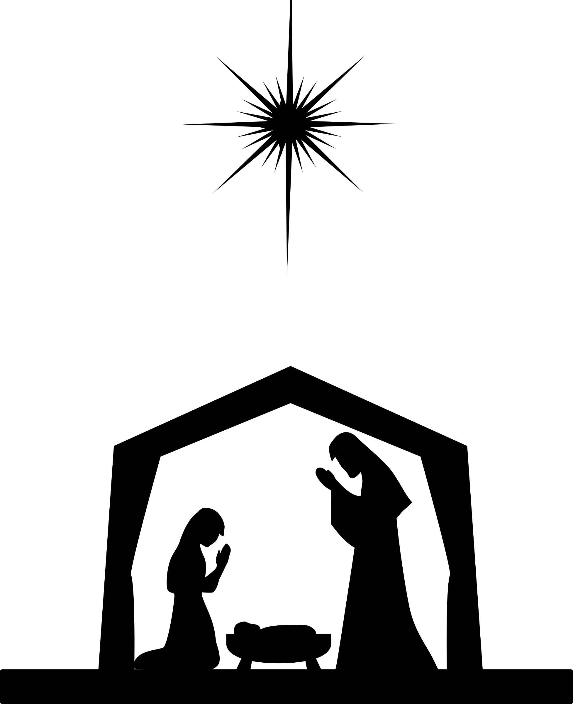 **Road To Bethlehem **

We all have our own Road To Bethlehem, a path that resonates with our life’s trials and joys; a journey that reconnects us to remembrance of what is holy and sacred to our hearts. As children we are born with wonder and excitement at this beautiful world and this gift of life we have been endowed with. Children represent everything good and exuberant; with imaginations that know no limits and aspirations that bear no burdens. The joy of Christmas and the true meaning of the Christ child’s birth ring true to the innocence of youth when we are not lost in the rhetoric of doubts and society’s expectations that what we dream can’t always come to pass.

I disagree that dreams lose their brilliance as life progresses. We each have inside of us a desire for greatness, a chance to shine that resonates with our inner creativity and intentional ability to excel! We are creators in the greatest time, holding lanterns to brighten the way for ourselves and others who are looking to find refuge from darkness and discouragement. Christ was born to bring hope and everlasting light! We are God’s children and we are each on our own Road To Bethlehem, living through ups and downs, joys and losses, smiles and tears. This Road To Bethlehem asks each of us to stretch ourselves sometimes beyond what we think we can bear; yet this road also brings greater understanding of ourselves and our teachable hearts in ways we could never have predicted.

When I think of the dusty, worn streets that Joseph and Mary traveled on to reach a place of rest that Christmas Eve so long ago, I can close my eyes and imagine the scents of spices, the voices of those who were pushing through crowds in the hustle and bustle of finding accommodations for the night. I can hear the angels that heralded the coming of the Savior’s birth as they sang to the lonely shepherds watching over their sheep. I can also hear the cries of those sheep as the shepherds herded them on through the darkness of that cold night guided by a glittering lone star leading them on their way--a compass for their weary hearts. I can see the silhouettes of the three wisemen as they journeyed on their camels through the desert following that same compass to bring gifts of gold, frankincense and myrrh to the holy family sometime after Christ’s birth.

I sense Mary and her discomfort as she rode on the donkey days away from giving birth. I can hear the animals in the stable as she and Joseph prepared for labor. I’m awed to think that Joseph may have been the only one present to assist Mary. Their Road to Bethlehem was filled with many opportunities to increase the bonds of love and sacrifice as they humbly travelled far away from family and friends as a newly



married couple. They both knew sorrow but celebrated over triumphs in their lives as they raised Jesus and his siblings in a loving home. I envision heavenly light glowing through the slats of the stable on Christmas Eve bringing warmth and comfort to those inside and outside. Whether we would imagine ourselves standing close to the glorious babe laying in the manger or gathering outside the stable amid others to pay our respects; we are offering up our vulnerable hearts and celebrating the Christmas spirit when we stand as a witness of this awesome experience and promise to share that gift with others through our love and service. When we remember Him, we remember our true power and strength to open our minds and let Christmas memories-past and present-resonate our beings; breaking through the hurts, fears and worries that we’ve carried as we let go and continually receive faith and love for ourselves and others while renewing our vision of our hopes, dreams and aspirations. Christmas Joy can be contagious, catch it and spread it around!

Years ago, after I graduated from college, I was able to visit Jerusalem and immerse myself in the wonderment of seeing images from the scriptures come to life as we walked the paths that Jesus walked. At most of the tourist sites, there were tables offering hand-crafted olive wood miniature nativity sets. I wanted to purchase one of these even though it was outside of my budget. I felt like if I did buy one, it had to be at a special place on the tour. I hesitated to purchase one until we visited the church that was built over the place where it is believed Jesus was born. As I stood in that holy place, thinking of what had transpired there, I knew I needed to own a souvenir of this monumental event.

When my tour bus first arrived at the Church of the Nativity in Bethlehem there were no street vendors selling the olive wood nativity sets. As we were boarding the bus at the end of the tour, I saw a vendor who was unloading olive wood nativity sets from his truck. Excited, I approached the vendor and bought a beautiful nativity set on my first ever charge card; maxing it to its small limit. Despite that, I didn’t feel any remorse for this inspiring souvenir that I have cradled, treasured and displayed every Christmas since then. At first my Mom was concerned I had maxed out my new charge card; but after seeing my nativity displayed at my house that next Christmas, she was inspired to purchase her own olive wood nativity set while visiting Jerusalem a while later.

I love pondering all things Christmas while curled up on my living room couch, Christmas music softly playing in the background, sipping Peppermint Hot Cocoa, cocooned in my warm beige afghan, my Road To Bethlehem essential oil blend diffusing through the house-conjuring up images of dusty roads and spices from long ago, while next to me on the table is my Bethlehem nativity set. As I see Mary and Joseph kneeling by baby Jesus, I think about how the world changed so many nights ago and the reverence of that event surrounds my soul.



I love to decorate for the holidays and a couple years ago I opened our home to family and friends by hosting small open houses, so they could enjoy the sights, sounds and smells of Christmas with me. I designated a few days with certain hours to fit people’s busy holiday schedules. Because there was an open house format for these days in December, it was a fun surprise to see who showed up to each event. One cold wintery night with snow falling outside, I wondered if anyone would make it because of the weather. I decided if they had the courage to venture out that night and make it to my house, they deserved to have the full experience; so, with hope in my heart I warmed Peppermint Hot Cocoa, assembled my Hot Cocoa Bar, heated my Holiday Spice Cider and laid out my Christmas Brownies. My Winter Magic essential oil blend was in the diffuser, beautiful Christmas harp music was playing in the background and the Christmas lights on my multiple Christmas trees and garland were lit which gave my house a festive feel. I was elated and sat myself down on my living room couch to wait for my guests.

As I looked past the flocked Christmas tree in my living room, I watched the snow fall through the view of my front window. I was mesmerized by the excitement and enchantment of a white Christmas and found myself enjoying the view of my maroon and gold decorated tree with its lit-up Christmas village beneath. I thought of all the village homes, shops and village people meandering around and was caught up in thinking of all the wonderful things of Christmas. Like giving and receiving of gifts, Santa, Christmas Eve traditions, Christmas day family dinners and the way the world seems to be filled with an extra dose of kindness, charity and positivity during this wonderful season. I said a silent prayer that I could spread this wonderful feeling with whomever was able to come and that their hearts would feel the Christmas spirit that was slowly filling my heart. I knew deep in my soul that whomever needed to be there would show up.

As time passed, I found myself not wanting to move from the couch, touched by the stillness and quiet moments I was experiencing. I wanted to be a courteous host, but I felt a longing to freeze time and linger longer in my thoughts. I stayed there and allowed myself to self-reflect in Christmas bliss, satisfied and happy in my contentment. I sang along to the Christmas songs playing in the background and felt free and centered. As more moments past and the snowfall outside increased, I realized I may not have any visitors that night. I was sad because I thought about how much I wanted to share these feelings I was having with someone who may need to be lifted up at that time. I thought of the work I had put into preparing yet as I drank my Spiced Cider and ate one of my Christmas brownies, I paused and realized that I was the one who had needed to come to my own open house. I had been so busy that season prepping for Christmas and trying to squeeze in all my socializing that I hadn’t taken time to sit by my tree and appreciate my nativity set. I was the one who needed to be lifted up that night and immersed with the Christmas spirit.



As this realization sat in, I closed my eyes and said a prayer of thanks to God knowing I didn’t need visitors that night; I needed quiet, uninterrupted meditating moments as I thought of that Road To Bethlehem characterized by the shepherds, wiseman, sheep, cows, camels and of course the holy family depicted in my nativity set. I reflected on my own Road To Bethlehem, how life has twists and turns we don’t expect yet there is joy and laughter all around, love from family and friends and a loving God who knows who we are. My niece made a wooden sign that reads “Gather” that sits by my tree, and just like the shepherds, wisemen and animals we too gather around with loved ones during the holidays whether that be a Christmas tree, a kitchen table or a beautiful nativity set as we celebrate this poignant time of year.

During my reflecting that night I also contemplated the fragility of life and how we need to hold beautiful memories close to our heart; how having a vulnerability humbles us to be like the Christ child-and how it is important to find stillness every day; not just at Christmastime. Stillness that reconnects us with our inner child’s hope and faith, reminding us that dreams are beautiful and achievable; that it’s never too late to believe that we do not travel our Road To Bethlehem alone. We are surrounded with strength, courage and innate power being guided by our desire to spread joy all year round.

My father sings a wonderful song called “Where You There” about that Christmas night. The lyrics ask: “Where you there on that Christmas night, when the world was filled with a holy light?” Our own Road To Bethlehem is filled with a holy light. May you find that light this Christmas season and spread it around as you continue on your Road To Bethlehem! May Christ’s love encircle you and you see the miracle of His birth.

MERRY CHRISTMAS

**Enjoy your Road To Bethlehem** **blend a few different ways**

1. **DIFFUSER DRAM ONLY**: **Diffuse a few drops of the blend in your diffuser and let the scent permeate your house**
2. **SPRAY BOTTLE**: **(shake bottle before)**

**Spray the bottle spray onto the palms of your hands, cup your hands by your nose~inhale the scent**

**Spray the bottle spray in front of you and inhale the scent as a mood lifter**

**Spray the bottle spray on yourself as a cologne\perfume**



**Oils of Road To Bethlehem**

1. **Myrrh**: Mother Oil. Trusting the good things of life, connection and nurturing. In Biblical times it was used as incense during temple rituals. It was one of the three oils the wisemen brought to baby Jesus.
2. **Wild Orange**: Oil of Abundance. Creativity and positivity. Anytime pick me upper: Put 1 drop on palm of hand, rub palms together, cup hands by nose and breathe in. Chocolate Orange Hot Cocoa: 1 drop in a cup of Cocoa (yes, it’s edible).
3. **Frankincense**: King of Oils. Oil of Truth. Spiritual enlightenment and wisdom. In Biblical times, it was considered holy and was used in incense and during religious ceremonies. It was one of the three oils the wiseman brought to Jesus.
4. **Sandalwood**: The Oil of Sacred Devotion. Calms the mind, great for peace and meditation. Sandalwoodis known to be one of the oldest materials used. In the Bible it was used for incense and perfume.
5. **Clove**: The Oil of Boundaries. Clove encourages independence and letting go of negativity. Clove oil can be substituted for clove spice in cooking. In Biblical times it was seen as a very rare spice.
6. **Douglas Fir**: The Oil of Generational Wisdom. It encourages connection to all generations-past and present. Great for diffusing while doing genealogy or when reminiscing on beautiful memories.
7. **Cinnamon**: This Oil encourages strong relationships based on mutual love and respect. Cinnamon Hot Cocoa: 1 drop in a cup of Cocoa (yes, it’s edible). Cinnamon oil was one of the oils Moses was instructed to take with him in Exodus 30:23.
8. **Cassia:** The Oil of Self-Assurance. Cassia encourages confidence and courage. It has a similar smell to cinnamon oil. In Biblical times, Cassia oil was part of Moses’ holy anointing oil. It was also used as an incense in the temple.
9. **Juniper Berry**: The Oil of Night. Juniper Berry encourages balance between light and dark in the way that we view ourselves and the world. Stressed? Put 1 drop on palm of hand, rub palms together, cup hands by nose and breathe in to relax.

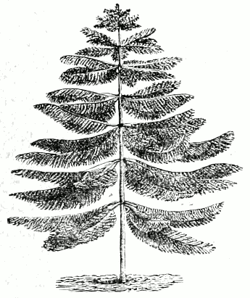

[This Photo](https://commons.wikimedia.org/wiki/File:Araucaria_columnaris.png) by Unknown Author is licensed under [CC BY-SA](https://creativecommons.org/licenses/by-sa/3.0/)

1. **Cypress**: The Oil of Motion and Flow. It encourages balanced energy and adaptability. In Biblical times, cypress was celebrated as a symbol of strength, security and prosperity.

Symplee Celebrations [www.symplee](http://www.symplee)celebrations.com

Suzette Rose (801) 372-8609